**CSC 2024 Database Technology Coursework 1**

**Michael Rumley (B5025189)**

1. 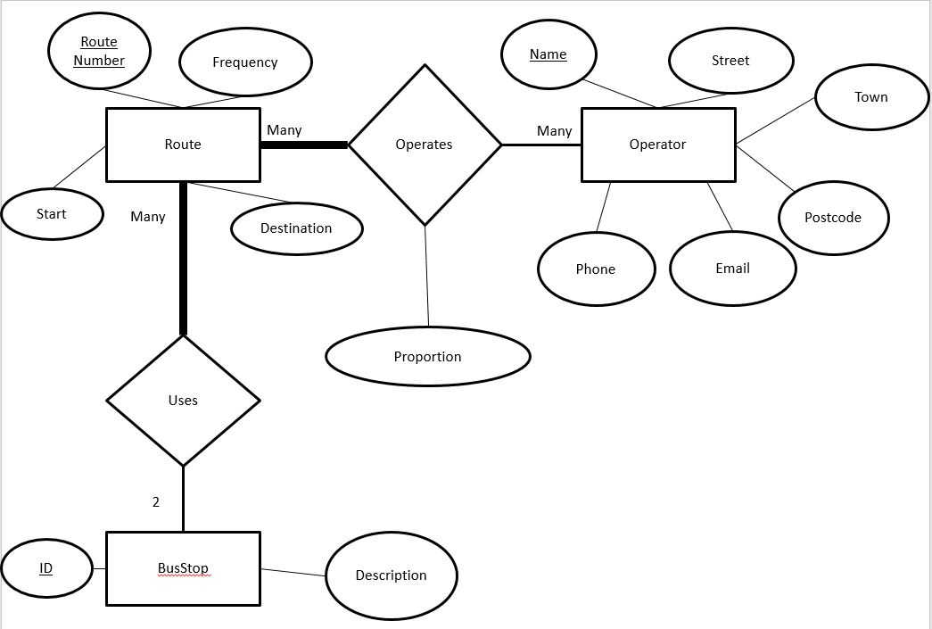

**Operator Table**

CREATE TABLE `Operator` (

`Name` varchar(45) NOT NULL,

`Street` varchar(45) DEFAULT NULL,

`Town` varchar(45) DEFAULT NULL,

`Postcode` varchar(45) DEFAULT NULL,

`Email` varchar(45) DEFAULT NULL,

`Phone` varchar(45) DEFAULT NULL,

PRIMARY KEY (`Name`)

) ENGINE=InnoDB DEFAULT CHARSET=latin1$$

**Route Table**

CREATE TABLE `Route` (

`Route_Number` varchar(45) NOT NULL,

`Frequency` int(11) DEFAULT NULL,

`Start` int(11) DEFAULT NULL,

`Destination` int(11) DEFAULT NULL,

PRIMARY KEY (`Route_Number`),

KEY `Start` (`Start`),

KEY `Destination` (`Destination`),

CONSTRAINT `Destination` FOREIGN KEY (`Destination`) REFERENCES `BusStop` (`ID`) ON DELETE CASCADE ON UPDATE SET NULL,

CONSTRAINT `Start` FOREIGN KEY (`Start`) REFERENCES `BusStop` (`ID`) ON DELETE CASCADE ON UPDATE SET NULL

) ENGINE=InnoDB DEFAULT CHARSET=latin1$$

**BusStop Table**

CREATE TABLE `BusStop` (

`ID` int(11) NOT NULL,

`Description` varchar(45) DEFAULT NULL,

PRIMARY KEY (`ID`)

) ENGINE=InnoDB DEFAULT CHARSET=latin1$$

**Operates Table**

CREATE TABLE `Operates` (

`Route_Number` varchar(45) NOT NULL,

`Name` varchar(45) NOT NULL,

`Proportion` int(11) DEFAULT NULL,

PRIMARY KEY (`Name`,`Route_Number`),

KEY `Name` (`Name`),

KEY `RouteNumber` (`Route_Number`)

) ENGINE=InnoDB DEFAULT CHARSET=latin1$$

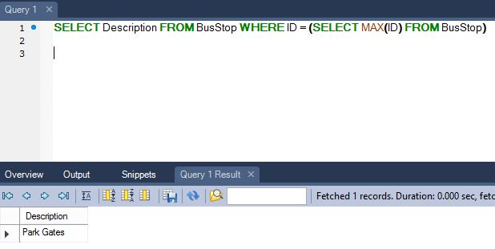

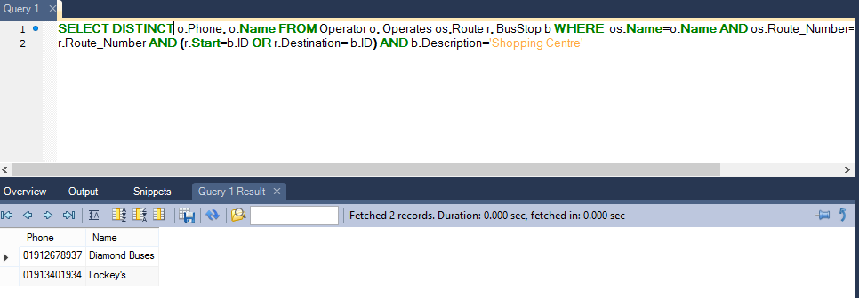

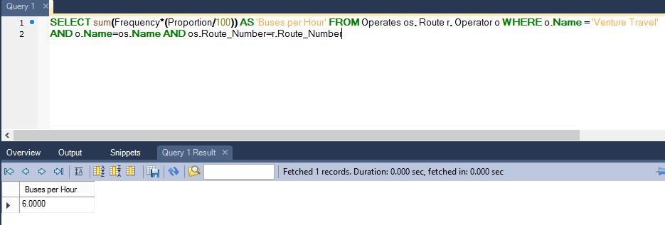



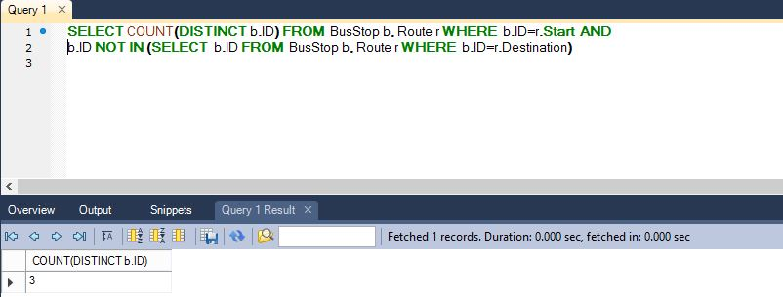

2. 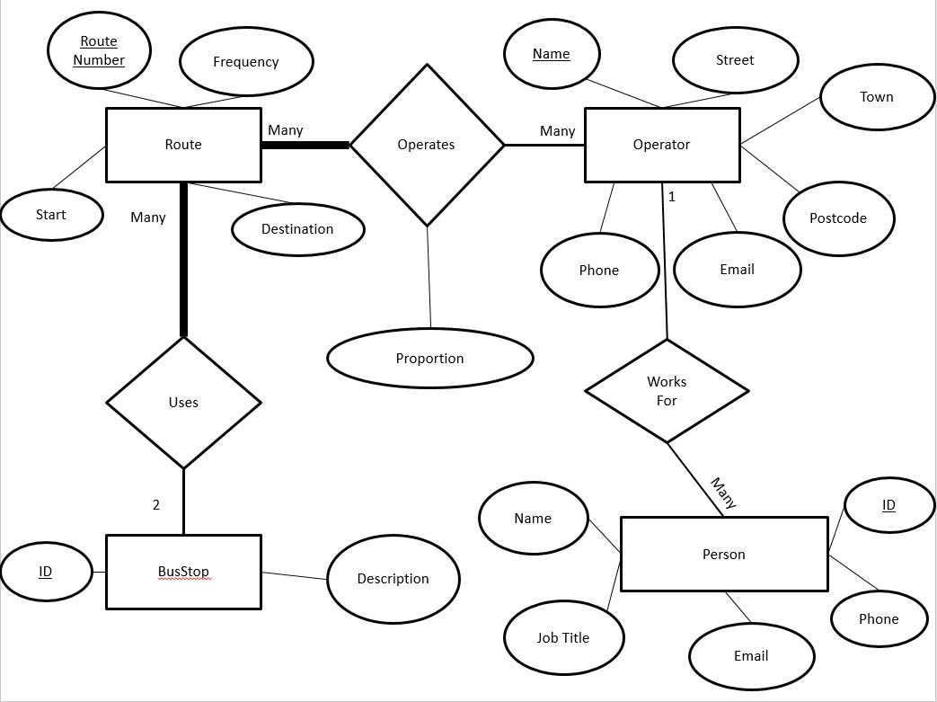

E/R Table:

* Remove the ‘Start’ and ‘Destination’ attributes of the Route class
* Change the 2 to many relationship between Route and BusStop to a many to many relationship

Database:

* Remove the ‘Start’ and ‘Destination’ columns from the Route table
* Create a new table called ‘uses’
* The table ‘uses’ has column headings ‘route number’ and ‘ID’
* ‘route number’ has a foreign key to the same column in ‘route’
* ‘ID’ has a foreign key to the same column in ‘BusStop’